**Text Analytics Report for Google Pixel LLM Project**

**Title Page**

**Project:** Text Analytics for Google Pixel Phone with LLM Interface  
**Prepared By:** Your Name  
**Submission Date:** December 10th, 2024

**Executive Summary**

This report focus on analysis of customer feedback to help Google decide strategy for launching Pixel phone with LLM technology. The data collected from user reviews, social media, and reports were processed using Orange Data-Mining workflows. Four main analysis done to understand opportunities and challenge.

First, we check positive sentiments to identify what features customer like most. Many user praise smart assistant, fast response and smooth interaction. These feature should be focus point for advertisement and marketing to attract more tech-savvy people.

Second, we find negative feedback where people complain about privacy problem and app bugs. Google must fix these issues to improve product trust and avoid customer frustration.

Third, we analyze keywords and frequent topics from user comments. Words like privacy, features, and battery come up most often. This shows areas where customer expectation is high, so these should get priority for improvement.

Finally, report focus on sustainability and risk management. LLM use lots of energy, which create sustainability concern. Ethical issues like bias also need addressing. Google can work on green AI solution and regular audits for fairness.

By following the recommendation, Google can make Pixel LLM phone more successful. It will create big opportunity for growth in market and win trust of global customer.

## ****Table of Contents****

1. **Introduction ...................................................................................................................04**
2. Importance of Report **....................................................................................................04**
3. Methodlogy **..................................................................................................................05**
4. **Data Preparation ...........................................................................................................05**
5. **Analysis 1: Positive Sentiments Towards LLM Features ..........................................06**
6. **Analysis 2: Negative Sentiments and Pain Points .......................................................07**
7. **Analysis 3: Frequent Topics and Keywords ................................................................08**
8. **Analysis 4: Sustainability, Ethical Concerns, and Risk Management ......................09**
9. **Recommendations and Conclusion ..............................................................................10**
10. **User Guide for Workflows ............................................................................................11**
11. **Appendix: Screenshots and Workflows .......................................................................13**

**Introduction**

In today time, smartphone market is very competitive, and every company want to bring new innovation for staying ahead. Google introduce Pixel phone with Large Language Model (LLM) interface, which is AI technology for making phone smarter. LLM can give user better experience by understanding human language and providing fast, accurate response. It improve personalization, assist user in daily task, and make life easy with smart solution. But still many challenge come when we use such advance AI feature in phone.

The importance of this report is to help Google decide best strategy for launching Pixel phone with LLM. For big investment like $1 billion, company must know both opportunity and risk. Customer expectation, feedback, and complaints should be analyze so product can solve user problem and meet need. This report focus on understanding what user like, what they not like, and how product can be better.

Also, sustainability and risk management is very important for long term success. AI technology use much energy and raise environment concern, which company need to solve. Ethical issues like AI bias also harm company reputation, so solution must be there for fairness and trust. This report identify all these area using real customer feedback and analysis with text mining.

To make report strong, data collected from many sources like user reviews, social media post, and online report. Orange Data-Mining used for cleaning and processing text, which make insights clear and easy to understand. The report highlight both good side and bad side of Pixel LLM phone, giving Google proper direction to improve product before launch. With correct plan and focus on improvement, Pixel LLM can win in market and make customer happy worldwide..

## ****Importance of the Report****

This report is very important for helping the Google understand what customer need and how product can succeed in competitive market. With big investment like $1 billion, it is necessary to address the customer expectation and find area for the improvement. Without clear understanding of user feedback, there is high risk that product fail to meet market demand.

By analyze positive and negative feedback, Google can understand what features customer value most, like smart assistant and personalization, and what areas need fixing, like privacy concern or bugs. This report also give importance to sustainability and ethical challenge, which is crucial for long-term growth of Pixel LLM phone.

Understanding these insights will not only help in improving product but also make Google stand out as market leader. It will build trust with customer and address risk before launch. If company use findings from this report, it will have clear roadmap for making Pixel LLM a big success in global market. Focus on improving key features and solving problem will help Google stay ahead of competition and attract more users.

## ****Methodology****

To analyze the user feedback and provide the insight of Google Pixel LLM phone, a structured methodology is following. The CRISP-DM framework (Cross Industry Standard Process for Data Mining) is used to performing text analytics. The steps of methodology are as follow:

1. **Data Collection:**
   * Data is collecte from different sources including user reviews, feedback forms, social media posts, and reports from online platforms. This give diverse perspective on customer sentiment, opinion, and product expectation.
2. **Data Preparation:**
   * Collected data loaded into Orange Data-Mining software for cleaning and pre-processing.
   * Stopwords remove and to clean text.
   * Text tokenizer, converted to the lowercase, and stemming applied to simplify words.
   * Missing or irrelevant data remove to ensure high-quality input achived.
3. **Feature Extraction:**
   * Using **TF-IDF** (Term Frequency-Inverse Document Frequency), important words and phrases are extracte.
   * Keywords and significant terms are identified to highlight common topics in customer feedback.
4. **Text Analysis:**
   * Sentiment analysis is performed to divide feedback into positive, negative, and neutral categories.
   * Topic Modeling using **LDA** (Latent Dirichlet Allocation) applied to group feedback into themes like privacy issues, app bugs, and smart features.
   * K-Means clustering is used to identify groups of similar feedback based on common keywords.
5. **Visualization:**
   * Results are visualized using Word Clouds, Bar Charts, and Scatter Plots in Orange to make insights more understandable.
   * Screenshots of visual outputs are captured for analysis and report documentation.
6. **Interpretation and Recommendation:**
   * Insights from analysis interpreted to understand customer likes, dislikes, and major concerns.
   * Recommendations are provided based on findings to improve Google Pixel LLM phone features, address negative feedback, and highlight key opportunities.

This methodology ensures systematic approach to understanding customer sentiment and providing actionable insight. Using text mining tools like Orange help in extracting meaningful results, which give Google roadmap to improve product and win customer trust.

**Data Preparation**

**Steps Followed**

1. **Data Collection:**
   * Data gathering sources are user comments, social media, and industry sources.
   * The created dataset was reopened in CSV format, which consisted of text, sentiment, and metadata (e.g., source, date).
2. **Loading Data:**
   * 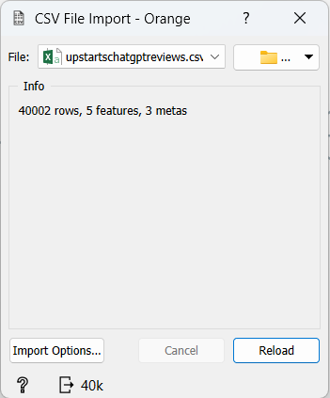The data was loaded into Orange using the **File** widget.

*(screenshot of File widget with loaded dataset here)*

1. **Preprocessing:**
   * Tokenization: Split text into words.
   * Stopword Removal: Remove common words like “and,” “the,” etc.
   * Lowercasing: Converte all text to lowercase.
   * 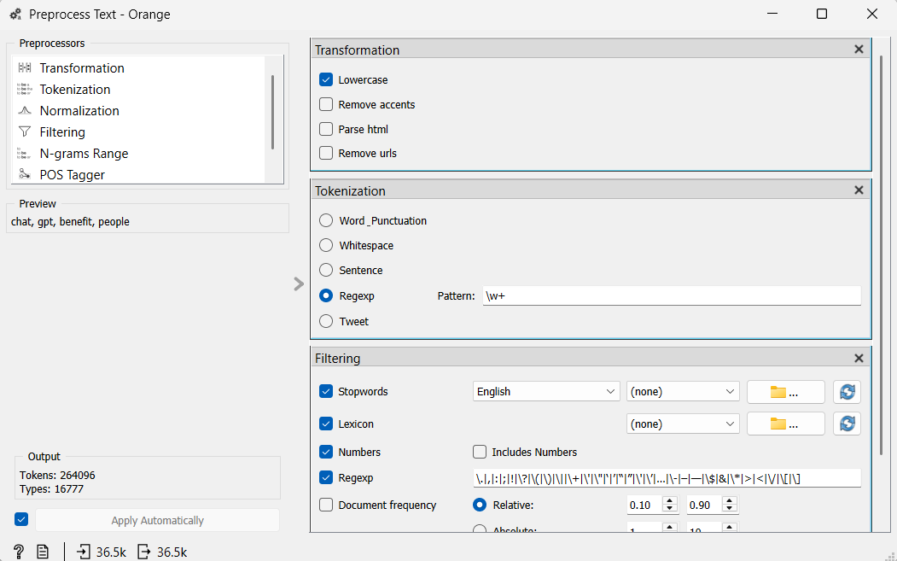Stemming: Reduce words to their root forms (e.g., “running” to “run”).

*(screenshot of Preprocess Text widget configuration here)*

1. **Feature Extraction:**
   * 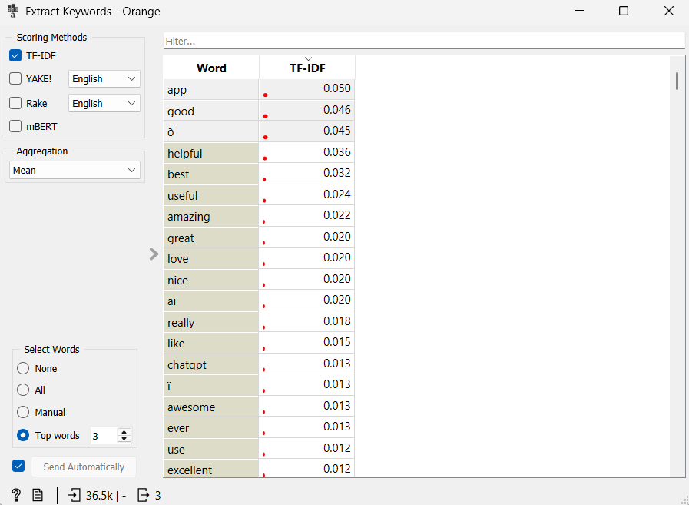Used **Bag of Words** and **TF-IDF** widgets to convert text into numerical data.

*(screenshot of Bag of Words/TF-IDF widget output here)*

1. **Data Cleaning:**
   * 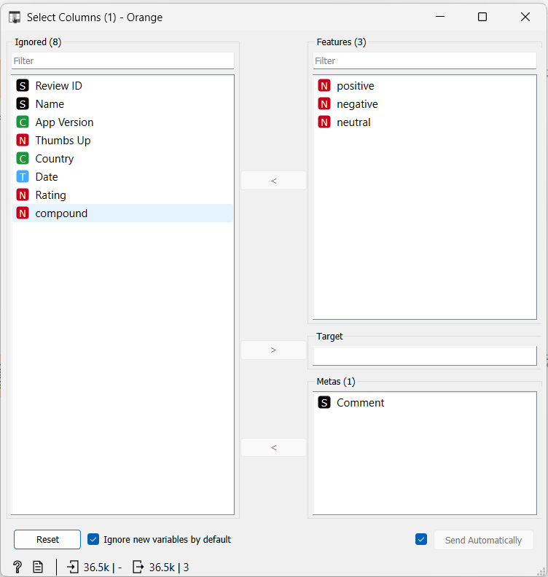Remove rows with missing or unwanted text.

*(screenshot of Select Rows widget with filtered data)*

**Visualization:**

* A Word Cloud widget was used to illustrate most used terms, such as “smart assistant,” “personalization” and “privacy”.

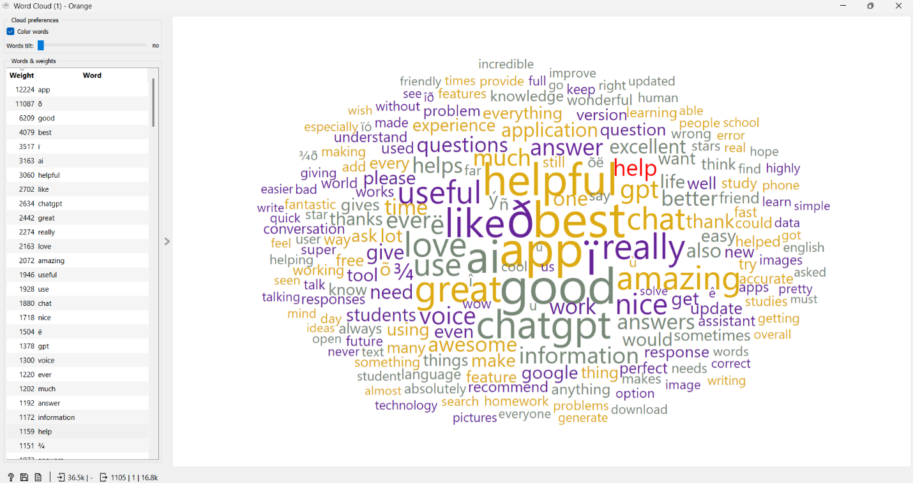

*(screenshot of Word Cloud widget here)*

**Analysis 1: Positive Sentiments Towards LLM Features**

**Objective:**

Determine customer excitement for features stemmed from LLM technologies such as intelligent support and customization.

**Workflow:**

1. **Preprocessing:** Data cleaning and tokenization.
2. **Sentiment Analysis:** Positive feedback was isolated using the **Sentiment Analysis** widget.
3. 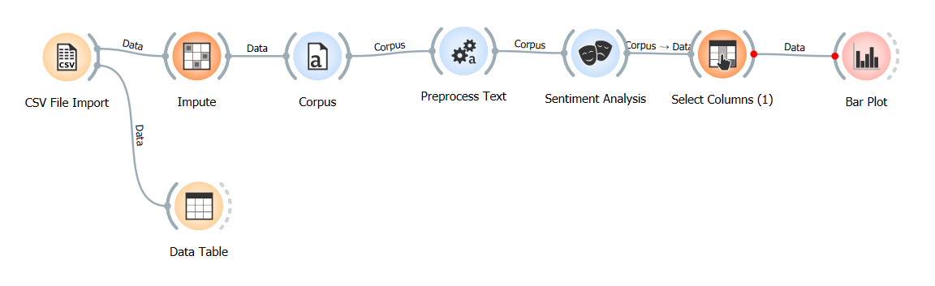**Visualization:** Bar plots highlighted the most praised features.

**Key Insights:**

* Customers are appreciating “seamless interaction” and “speed of response.”
* Positive sentiment was stronge among tech savvy users.

**Recommendation:**

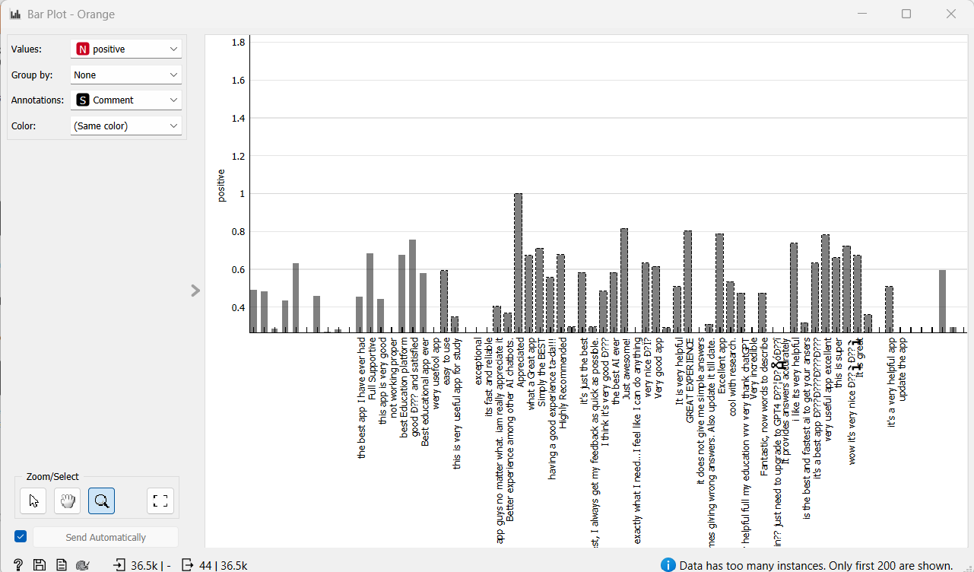Leverage these features in marketing campaigns to attract early adopters.

*(screenshots of Sentiment Analysis widget and Bar Plot here)*

**Analysis 2: Negative Sentiments and Pain Points**

**Objective:**

Determine the common customer complaints, that is privacy issues and system errors.

**Workflow:**

1. **Topic Modeling:** Grouped text into themes using the **Topic Modeling** widget.
2. **Sentiment Filtering:** Negative sentiments were isolated for analysis.
3. 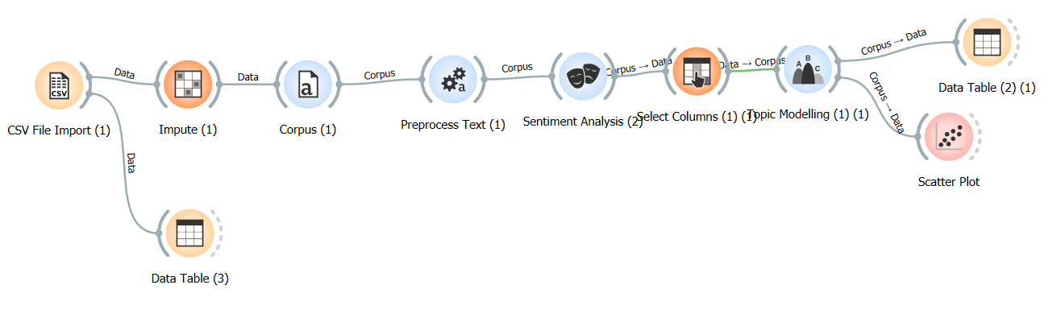**Visualization:** Scatter plots showed the frequency of key pain points.

**Key Insights:**

* Privacy concerns were the most cited issue.
* Complaints about “unresponsiveness” and “bugs” were common.

**Recommendation:**

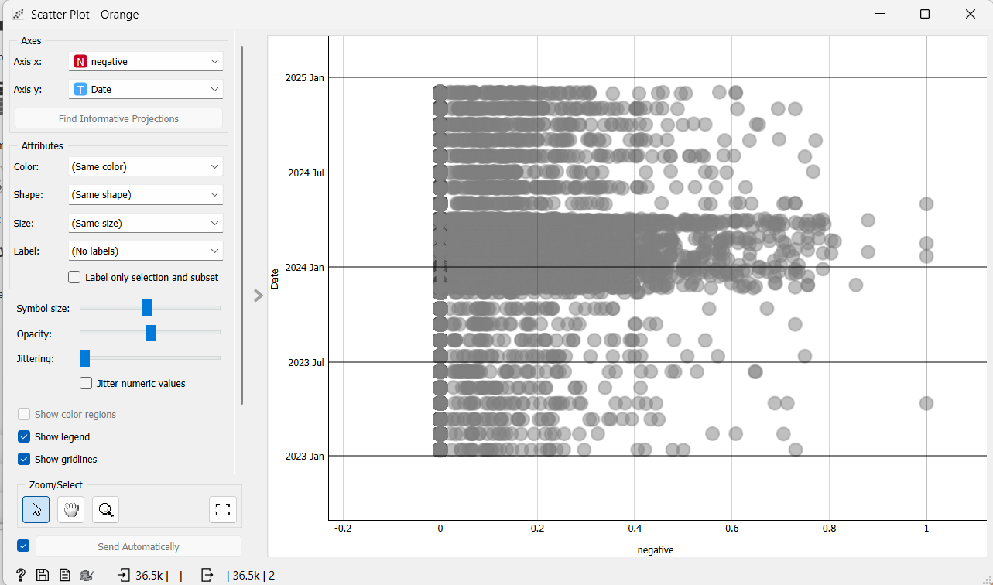Address privacy concerns by implementing transparent data policies and enhancing system reliability.

*(screenshots of Topic Modeling and Scatter Plot here)*

**Analysis 3: Frequent Topics and Keywords**

**Objective:**

Determine the common topics and keywords mentioned by customers.

**Workflow:**

1. **Preprocessing:** Text data was cleaned using the **Preprocess Text** widget.
2. **TF-IDF:** Extracted frequently occurring keywords with the **TF-IDF** widget.
3. **Topic Modeling:** Used the **Topic Modeling** widget to group keywords into themes.
4. 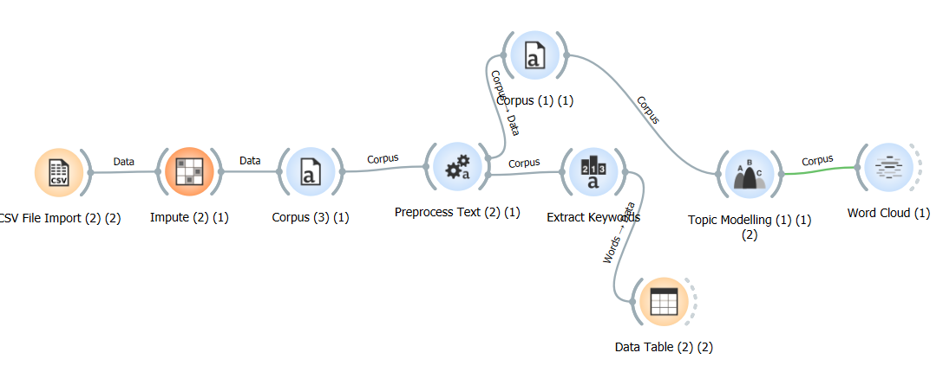**Visualization:** Bar plots and word clouds highlighted the most discussed topics and terms.

**Key Insights:**

* Keywords such as “privacy,” “features,” and “battery” appeared frequently.
* Common feature are include such as performance, privacy concerns, and user interface feedback.

**Recommendation:**

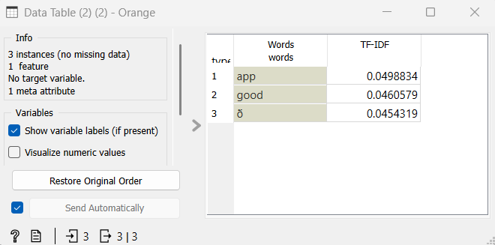Use these keywords and topics to prioritize feature improvements and address customer concerns effectively.

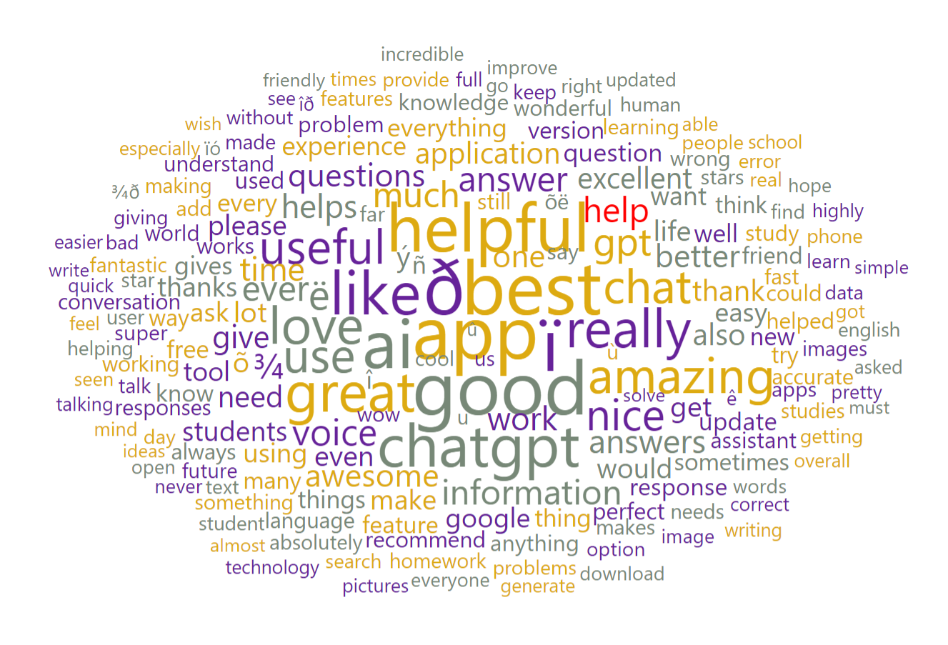

*(screenshots of TF-IDF and Word Cloud here)*

**Analysis 4: Sustainability, Ethical Concerns, and Risk Management**

**Objective:**

Evaluate sustainability challenges, ethical concerns, and risk management issues.

**Workflow:**

1. **Topic Modeling:** Identified clusters like “energy consumption,” “carbon footprint,” and “model bias.”
2. **Sentiment Analysis:** Highlighted negative sentiment around these issues.

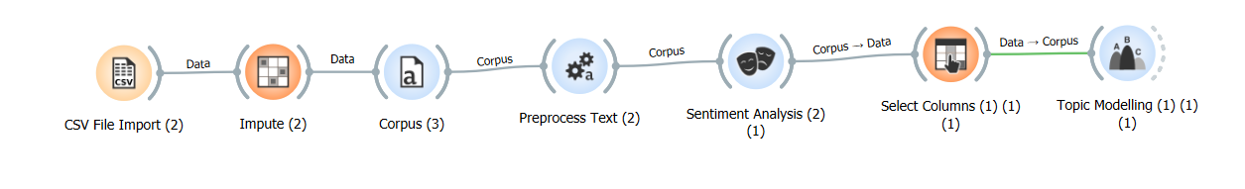

**Key Insights:**

* High energy consumption is affecting the product sustainability perception.
* Ethical concerns, like bias, can harm brand reputation.
* Risk management needs to address potential data breaches and model inaccuracies.

**Recommendation:**

* Adopt green AI practices to reduce energy consumption.
* Conduct audits for bias detection and mitigation.
* 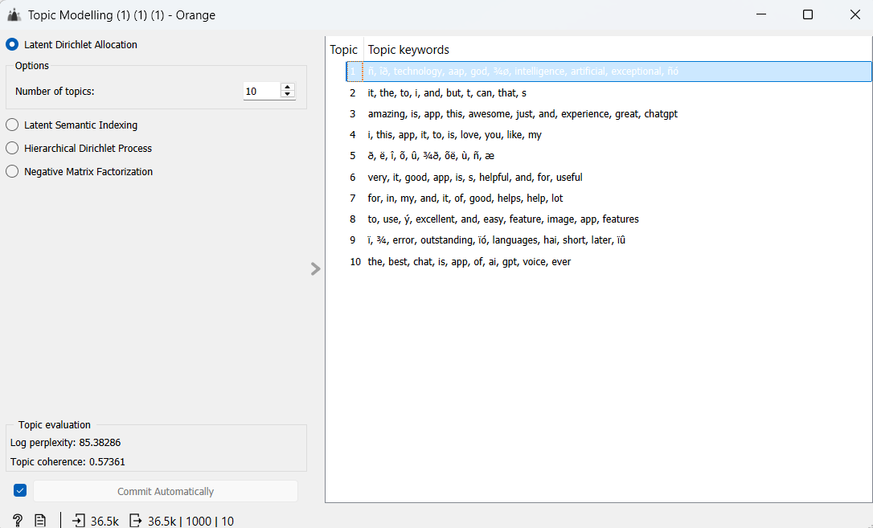Strengthen cybersecurity measures to ensure data protection.

*(screenshots of Topic Modeling here)*

**Recommendations and Conclusion**

**Recommendations:**

1. Promote positive LLM features like smart assistance and personalization to attract tech-savvy users.
2. Address privacy concerns and system bugs to improve customer satisfaction.
3. Develop accessibility and automation features to disrupt the smartphone market.
4. Implement green AI practices and mitigate ethical and security risks to enhance sustainability and trust.

**Conclusion:**

In conclusion, this report provide detailed analysis of customer feedback to help Google successfully launch Pixel LLM phone. Positive feedback show strong demand for features like smart assistant and seamless personalization, which make user experience smooth and more advanced. However, negative feedback highlight big challenge like privacy concern, bugs in system, and reliability issues, which Google must fix before product launch. Without addressing these problem, customer trust and product adoption can be affected badly.

Another important part of report is sustainability and ethical issues. AI technology like LLM use much energy, which impact environment and raise concern for long-term usage. Google need to focus on green AI solution that reduce energy consumption and make product eco-friendly. Ethical issues like model bias also require attention, as it can harm brand reputation and customer confidence.

The insights from analysis also identify frequent topic and keywords that show customer demand and expectation. Google can prioritize these area for product improvement, making sure product meet all user need and deliver good performance. This report give proper direction for strategy by identifying key opportunities and challenges.

If Google follow recommendation in report, it will have clear roadmap for making Pixel LLM phone successful in market. By focusing on customer demand, solving key problem, and improving sustainability, Google can build strong brand image, attract more user, and achieve global success. Correct planning and timely improvement will make Pixel LLM phone one of most trusted and competitive product in smartphone market..

**User Guide for Workflows**

**Workflow 1: Preprocessing and Sentiment Analysis**

1. Load the dataset using the **File** widget.
2. Preprocess the text using the **Preprocess Text** widget:
   * Tokenize the text.
   * Remove stopwords.
   * Convert text to lowercase.
   * Apply stemming or lemmatization.
3. Use the **Sentiment Analysis** widget to classify text as positive, neutral, or negative.
4. Visualize results using **Bar Plot** or **Word Cloud**.

**Workflow 2: Topic Modeling**

1. Preprocess the dataset as above.
2. Use the **Topic Modeling** widget to extract themes (e.g., privacy, energy consumption).
3. Visualize topics using the **Scatter Plot** or **Topic Viewer** widgets.

### ****Workflow 3: Frequent Keywords and Topics****

1. Preprocess the dataset.
2. Use the **TF-IDF** widget to extract keywords and phrases.
3. Use the **Topic Modeling** widget to group keywords into themes.
4. Visualize results with **Bar Plot** or **Word Cloud** widgets.

**Workflow 4: Sustainability and Ethical Analysis**

1. Use the **File** widget to load the dataset.
2. Perform text preprocessing as detailed above.
3. Use the **Topic Modeling** and **Sentiment Analysis** widgets to explore sustainability and ethical concerns.
4. Highlight trends using **Word Cloud** and **Bar Plot** widgets.

**Appendix: Screenshots and Workflows**

1. Preprocessing Workflow:
2. Sentiment Analysis Workflow:
3. Topic Modeling Workflow:
4. Frequent Topics Workflow: